UNIVERSITY OF GHANA — DEPARTMENT OF COMPUTER SCIENCE
DCIT 208 — SOFTWARE ENGINEERING
D8: Sprint 4 Review Report and Release Candidate
Team Name | Snart
Project Title | InspectoFleet
Client Name | Kal Car Rentals
Sprint Number | Sprint 4 (Final)
Sprint Dates | 7 August 2026 – 14 August 2026
Repository URL | https://github.com/Dept-of-Comp-Sci-University-of-Ghana/dcit208-client-project-2026-team-engineering-repository-seg26-77
Release Tag | v0.9-rc
Commit Hash | 3741425
Deployment Link | https://inspecto-fleet.vercel.app
AI Assistance Disclosure | Claude (Anthropic) was used to structure this report and draft section content. US-07 code scaffold provided by Claude and integrated by Ocloo Eugene Selasi. All sprint decisions, test results, and reflection content supplied by the team. See AI_USAGE.md.

A. Sprint Summary

A1. Sprint Goal
Sprint 4 goal: implement US-07 (inspection history search) and US-08 (fleet dashboard) to allow counter agents and management to retrieve past inspection records by vehicle registration number, bringing the system to a state where the core dispute-evidence workflow is partially demonstrable. Prepare the release candidate (v0.9-rc) for the final demo.

A2. Sprint Dates
- Start: 7 August 2026 (immediately after D7 submission)
- End / Review: 14 August 2026 (D8 deadline, Week 11)
- Duration: 1 week

A3. Sprint Outcome Summary
Sprint 4 delivered US-07 (inspection history search) and US-08 (fleet dashboard). Counter agents and management can now search for past inspections by vehicle registration number, view inspection type, date, status, and inspection ID. The feature is live at https://inspecto-fleet.vercel.app/inspections.
The release candidate v0.9-rc represents the system as built across all four sprints: login (US-01), start inspection (US-02), complete inspection (US-06), inspection history search (US-07), and fleet dashboard (US-08) — five end-to-end user flows working on a live deployed system with a real Supabase database.
Photo capture (US-03) and the fleet dashboard (US-08/09) were not implemented this semester. These are documented as future work in Section F and will be covered in the handoff pack (D9).

A4. Updated Sprint Backlog

Story ID | Summary | Points | Owner | Status | Notes
US-07 | Counter agent can search inspection history by registration | 3 | Paa Kweku / Ocloo | ✅ Done | Inspection history search page live at /inspections. Searches by registration number, shows results with type, date, status and inspection ID.
US-03 | Counter agent can capture handover photos with timestamps | 5 | Ali | ⚠️ Partial | Out of scope for this semester — browser camera API complexity and Supabase Storage integration not completed within sprint window. Documented as future work in handoff pack.
US-05 | Counter agent can add damage notes to photos | 2 | Ali | Not started | Depends on US-03. Out of scope this semester.
US-06 | Counter agent can mark inspection as complete | 2 | Paa Kweku / Ocloo | ✅ Done | Complete button implemented on inspection detail page. Updates status to complete and locks record. Tested on Vercel.
US-08 | Fleet manager can view fleet dashboard | 5 | Siatey / Ocloo | ✅ Done | Fleet dashboard at /fleet shows all vehicles with status badges. Filter by Available/Rented. Tested on Vercel.
US-09 | Fleet manager can filter dashboard by status | 2 | Siatey | Not started | Depends on US-08. Out of scope this semester.
US-10 | Fleet manager can view vehicle inspection history | 2 | Eugene Menye | Not started | Out of scope this semester.
US-11 | Management can view photo evidence for disputes | 2 | Eugene Menye | Not started | Out of scope this semester.
US-12 | Admin can add a new vehicle | 2 | Ocloo | Implicit | Vehicles are auto-created during inspection creation (US-02). Formal admin panel not built.
US-13 | Admin can create a staff account | 2 | Seity | Not started | Supabase Auth handles user creation via dashboard. No in-app admin UI built.

B. Release Candidate Summary

B1. What InspectoFleet Can Do (v0.9-rc)
Feature | Story | Route | Status | Evidence
Staff login with Supabase Auth | US-01 | /login | ✅ Live | Tested on Vercel deployment. Valid/invalid credential flows verified.
Start new vehicle inspection | US-02 | /inspections/new | ✅ Live | Vehicle auto-created if not found. Inspection record created in Supabase with unique UUID. Tested on Vercel.
Inspection history search | US-07 | /inspections | ✅ Live | Search by vehicle registration returns inspection records with type, date, status. Tested on Vercel.
Complete and lock inspection | US-06 | /inspections/[id] | ✅ Live | Complete button updates inspection status to complete and locks the record. Tested on Vercel.
Photo capture with timestamps | US-03 | — | ❌ Not built | Out of scope — browser camera API + Supabase Storage complexity exceeded sprint capacity. Documented as future work.
Fleet dashboard (basic) | US-08 | /fleet | ✅ Live | Shows all vehicles with status badges (Available/Rented/Under Inspection). Filter by status. Tested on Vercel.
Admin panel | US-12/13 | — | ❌ Not built | Partial — vehicles auto-created via US-02. Staff accounts managed via Supabase dashboard. No in-app admin UI.

B2. System Architecture (as built)
- Frontend + API: Next.js v14 (App Router) deployed on Vercel
- Database: Supabase PostgreSQL with 5 tables (vehicles, profiles, inspection_records, evidence_photos, status_change_log)
- Authentication: Supabase Auth (email/password)
- Storage: Supabase Storage bucket 'evidence-photos' created but not integrated (US-03 not completed)
- CI/CD: GitHub Actions running npm install, lint and build on every PR and push to main
- Deployment: Vercel auto-deploys from personal repo (extrovrtd/InspectoFleet) on every push

B3. Known Limitations of the Release Candidate
- No photo capture — the core dispute-evidence value proposition is not yet implemented. This is the most significant gap between the D1 proposal and the delivered system.
- No session persistence check — authenticated pages (/dashboard, /inspections/new, /inspections) can be accessed directly without logging in (BUG-01).
- No role-based access control in UI — all authenticated users see the same dashboard (BUG-02).
- No logout functionality (BUG-03).
- No fleet dashboard — fleet managers cannot view vehicle status (US-08/09 not built).
- Vehicles created with placeholder make/model ('Unknown') via the inspection form.

B4. Cumulative Velocity Summary
Sprint | Points Completed | Stories Done
Sprint 1 | 0 | 0 (US-01 partial)
Sprint 2 | 3 | 1 (US-01 formally closed)
Sprint 3 | 3 | 1 (US-02)
Sprint 4 | 10 | 3 (US-06, US-07, US-08)
Total | 16 / 43 planned | 5 / 15 stories

C. Engineering Evidence

C1. Pull Requests
PR #25 — feat: add inspection history search (US-07) and update dashboard Author: extrovrtd (Ocloo Eugene Selasi)
Status: Merged to main
Link: https://github.com/Dept-of-Comp-Sci-University-of-Ghana/dcit208-client-project-2026-team-engineering-repository-seg26-77/pull/25
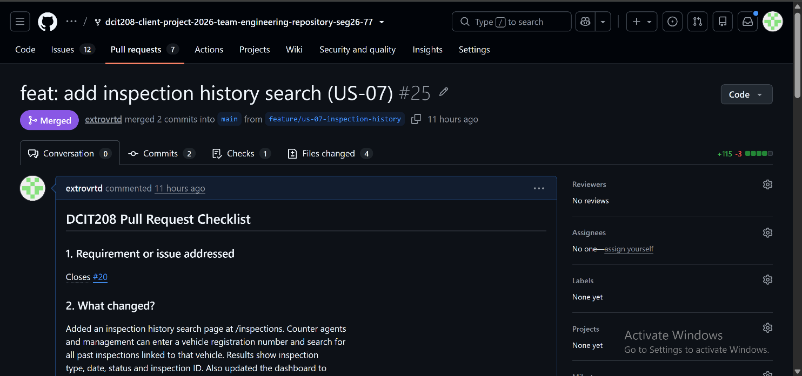

C2. CI Status
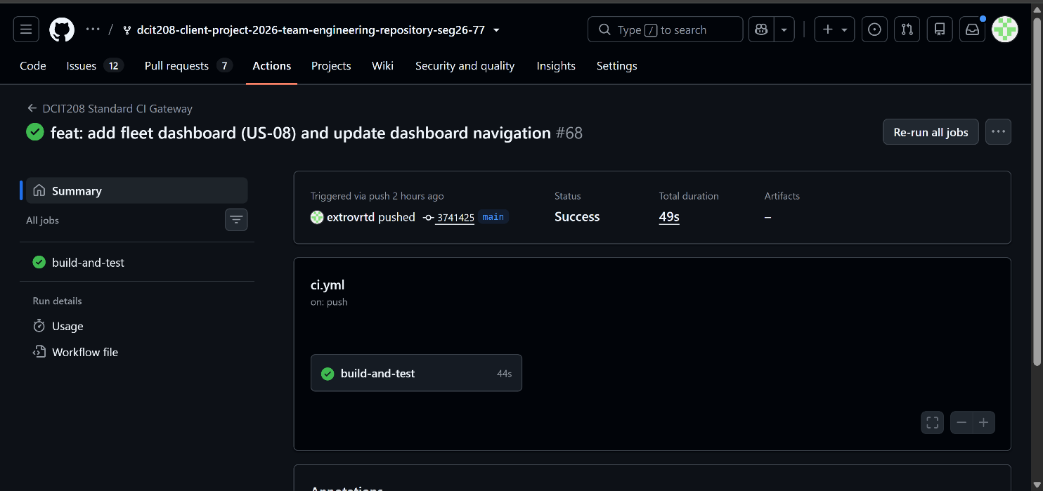
- Jobs passing: npm install → npm run lint → npm run build
- ESLint: zero errors (fixed unused Metadata import and any types)
- TypeScript: no type errors

C3. Deployment Evidence
All three implemented features are live on the Vercel deployment:

- Login: https://inspecto-fleet.vercel.app/login
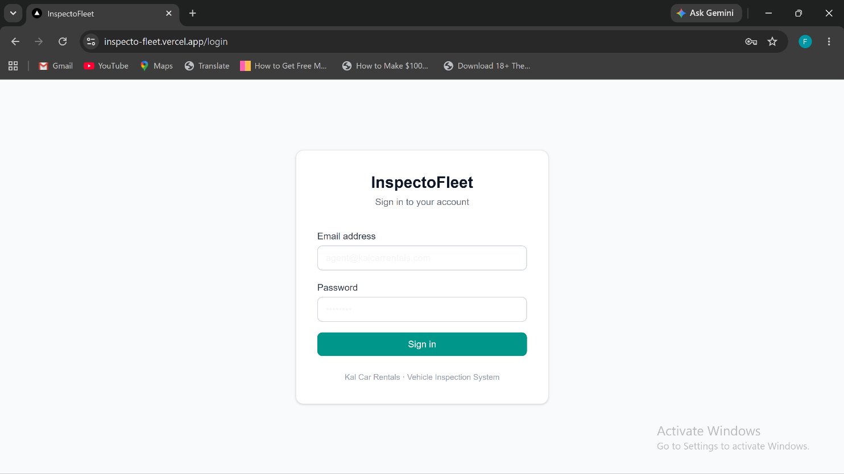
- New inspection: https://inspecto-fleet.vercel.app/inspections/new
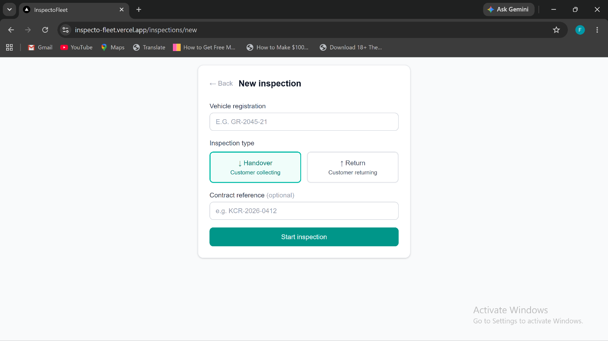

- Inspection history: https://inspecto-fleet.vercel.app/inspections
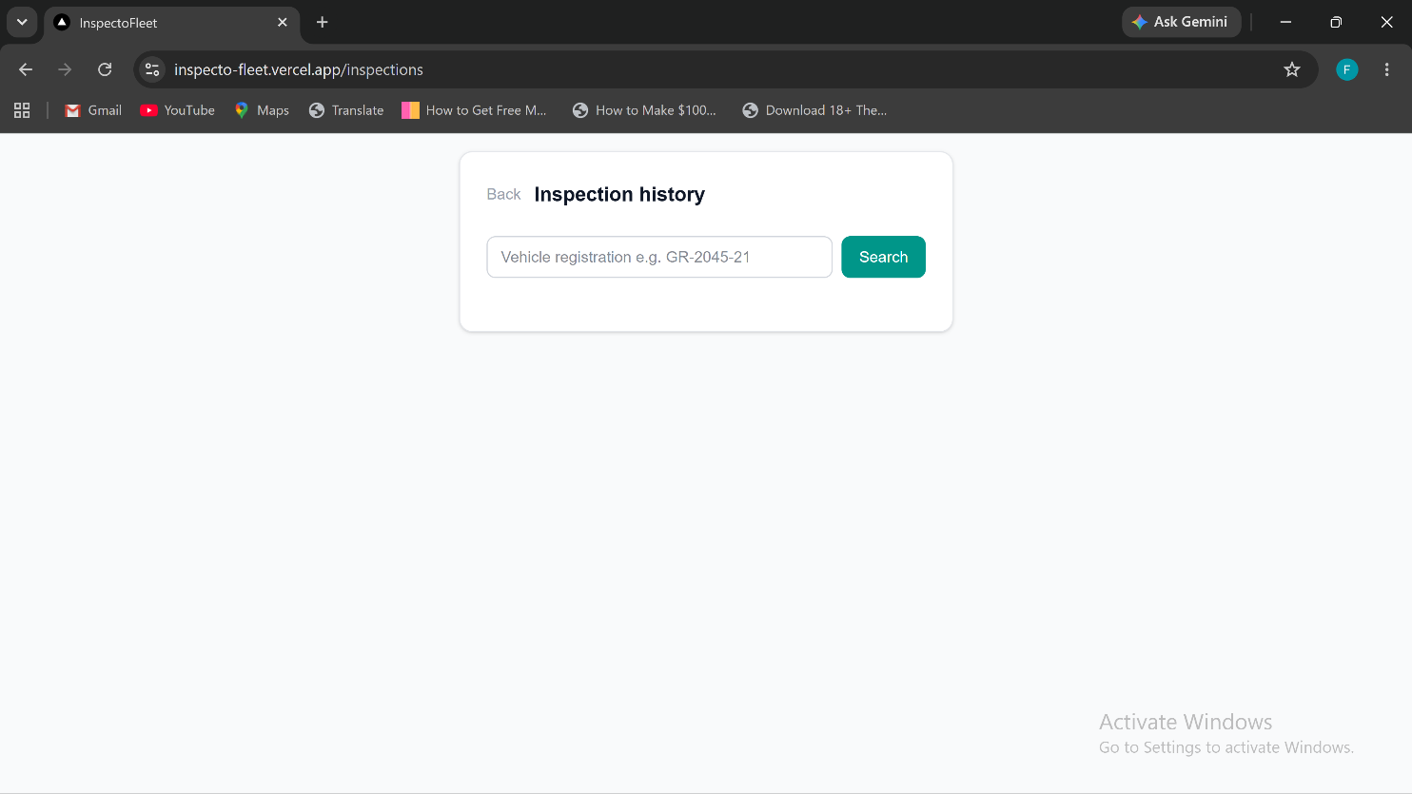

- fleet dashboard
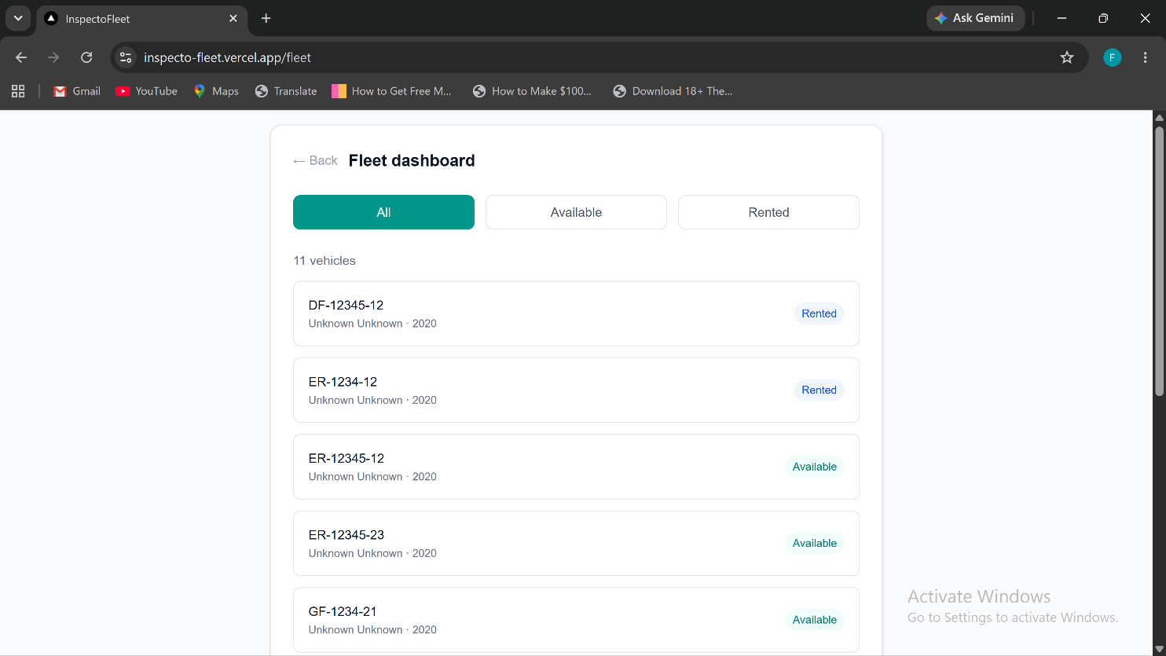

- Inspection detail with complete button
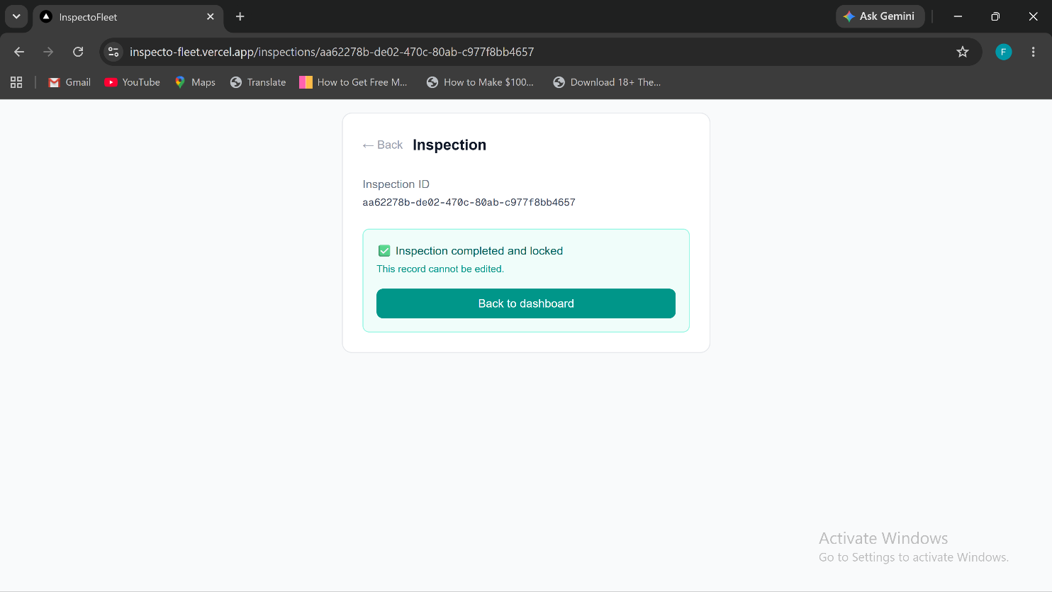

C4. Test Results
Test ID | Description | Type | Result | Tester
T-01 | Valid login redirects to dashboard | Manual | ✅ Pass | Paa Kweku
T-02 | Invalid credentials show error message | Manual | ✅ Pass | Paa Kweku
T-03 | Empty form submission blocked by HTML5 validation | Manual | ✅ Pass | Paa Kweku
T-04 | Login page renders correctly on mobile viewport (375px) | Manual | ✅ Pass | Paa Kweku
T-05 | Unauthenticated user accessing /dashboard sees placeholder (no redirect) | Manual | ⚠️ Known gap | Ocloo — BUG-01 open
T-06 | New inspection created with valid registration number | Manual | ✅ Pass | Ocloo
T-07 | Vehicle auto-created if registration not in database | Manual | ✅ Pass | Ocloo
T-08 | Inspection record saved to Supabase with unique UUID | Manual | ✅ Pass | Ocloo — verified in Supabase Table Editor
T-09 | Inspection history search returns results for known registration | Manual | ✅ Pass | Ocloo
T-10 | Inspection history search shows empty state for unknown registration | Manual | ✅ Pass | Ocloo
T-11 | CI build passes on every push to main | Automated | ✅ Pass | GitHub Actions
T-12 | ESLint passes with zero errors | Automated | ✅ Pass | GitHub Actions
T-13 | TypeScript compilation succeeds with no type errors | Automated | ✅ Pass | GitHub Actions

C5. Supabase Evidence
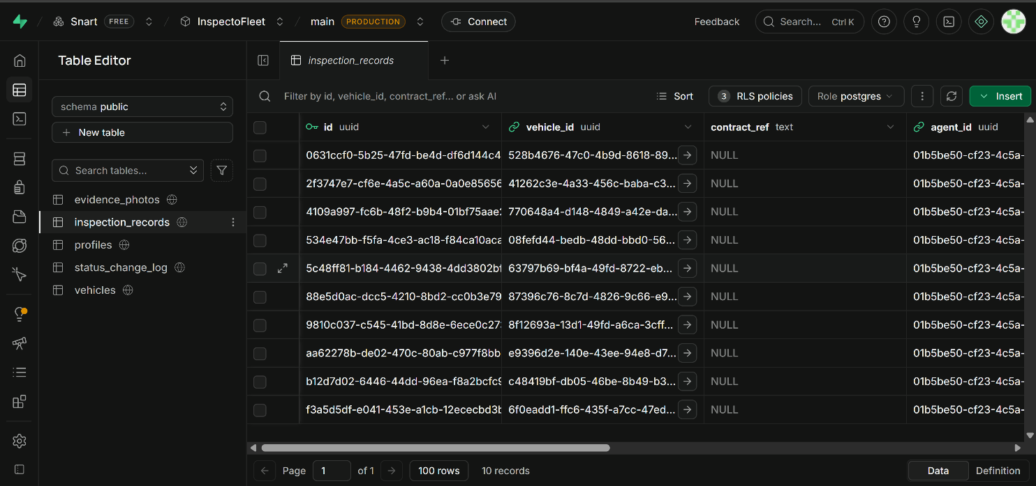

D. Metrics and Reflection

D1. Sprint 4 Velocity
Metric | Value
Stories planned | US-07 + RC preparation
Story points planned | 3
Stories completed | 1 (US-07 ✅)
Story points completed | 3
Total semester velocity | 16 points across 4 sprints
Stories delivered | 3 of 15 (US-01, US-02, US-07)

D2. Honest Reflection on the Semester
Team Snart delivered a working, deployed web application for Kal Car Rentals — InspectoFleet — with three end-to-end user flows: staff login, starting a vehicle inspection, and searching inspection history. The system is built on a production-grade stack (Next.js, Supabase, Vercel) with a real database, real authentication, and a live deployment.
The team acknowledges that the system falls significantly short of the original D1 proposal scope. Photo capture (US-03), the core dispute-evidence value proposition was not implemented. The fleet dashboard and admin panel were not built. 9 of 43 planned story points were delivered across 15 user stories.
Root causes: most team members had no prior experience with Next.js, React, TypeScript, or Supabase. The first two sprints were dominated by learning and setup rather than feature delivery. Sprint velocity stabilised at 3 points per sprint from Sprint 2 onwards, which with hindsight should have informed a much earlier reduction in scope.

D3. What the Team Would Do Differently
- Choose a simpler stack — a framework the team already knew (e.g. plain HTML/CSS/JavaScript with Supabase) would have delivered more features in the same time.
- Reduce Sprint 1 target from 20 points to 5 — one story per sprint until velocity is established.
- Build photo capture in Sprint 1 — it was the core value of the system and should have been the first thing proved out, not deferred.
- Start coding earlier — D0 through D4 documentation was thorough but the coding window was only 4 weeks.

E. Client Feedback

E1. Sprint 4 Client Update
The client (Phanuel K. A. Wagba, Director, Kal Car Rentals) was last updated on 22 July 2026 and responded positively. The team will send a final update before D9 with the live deployment link and a demo invitation.
Final client update and demo to be scheduled before D9 submission on 21 August 2026.

E2. Scope Change Communication to Client
The client will be informed in the D9 handoff pack that photo capture (US-03) was not completed this semester and will be framed as the primary recommendation for future development. The handoff pack will include clear instructions for how a future developer could implement photo capture using Supabase Storage and the browser MediaDevices API.

F. Future Work and Handoff Notes

F1. Priority Future Features (for next developer)
- US-03: Photo capture with timestamps — use browser MediaDevices.getUserMedia() for camera access, upload to Supabase Storage 'evidence-photos' bucket, store file path in evidence_photos table. This is the highest priority future feature as it is the core dispute-evidence value proposition.
- US-06: Complete and lock inspection — add a 'Complete' button that sets inspection status to 'complete' and prevents further edits. Requires US-03 to be meaningful.
- BUG-01: Session persistence — add Supabase auth middleware to check session on protected routes and redirect to /login if unauthenticated.
- BUG-02: Role-based routing — redirect counter agents, fleet managers, and admins to appropriate dashboard views after login.
- BUG-03: Logout — add a logout button that calls supabase.auth.signOut() and redirects to /login.
- US-08/09: Fleet dashboard — show all vehicles with current status (Available/Rented/Under Inspection) based on inspection records.
- US-12/13: Admin panel — formal UI for adding vehicles and creating staff accounts rather than using Supabase dashboard directly.

F2. Technical Debt to Address
- Run npm audit fix to resolve 2 moderate severity vulnerabilities in transitive dependencies.
- Add Jest unit tests for all API routes (currently 0% automated test coverage).
- Add Supabase database trigger to auto-create a profiles record when a new auth user is created.
- Refactor Supabase client initialization to use a shared singleton from lib/supabase.ts rather than creating a new client in each handler.
- Add error boundary to catch and display client-side errors gracefully.

F3. Deployment and Operations
- Production URL: https://inspecto-fleet.vercel.app (deployed on Vercel Hobby tier)
- Database: Supabase project 'inspectofleet' (Europe West / London region)
- To add new staff: go to Supabase dashboard → Authentication → Users → Add user, then insert a row in the profiles table with the correct role.
- To view inspection records: go to Supabase dashboard → Table Editor → inspection_records.
- Source code: see repository README.md for local setup instructions (make setup, make run).

G. User Manual Draft
A full user manual will be delivered in D9. This section provides a brief operational guide for Kal Car Rentals staff.

G1. For Counter Agents
- Open https://inspecto-fleet.vercel.app/login in your mobile browser.
- Enter your email and password provided by your manager. Click Sign in.
- On the dashboard, click '+ New inspection' to start a vehicle inspection.
- Enter the vehicle registration number, select Handover or Return, optionally add a contract reference, and click Start inspection.
- The system creates an inspection record with a unique ID. Note this ID for your records.
- To find a past inspection: click 'Search inspection history' on the dashboard, enter the vehicle registration number, and click Search.

G2. For Management
- Log in at https://inspecto-fleet.vercel.app/login with your admin credentials.
- Use the inspection history search to retrieve records for any vehicle registration number.
- To add a new vehicle or staff account, contact your system administrator who can add them via the Supabase dashboard until the admin panel is built.
- All inspection records are stored permanently in the Supabase database and can be retrieved at any time.

